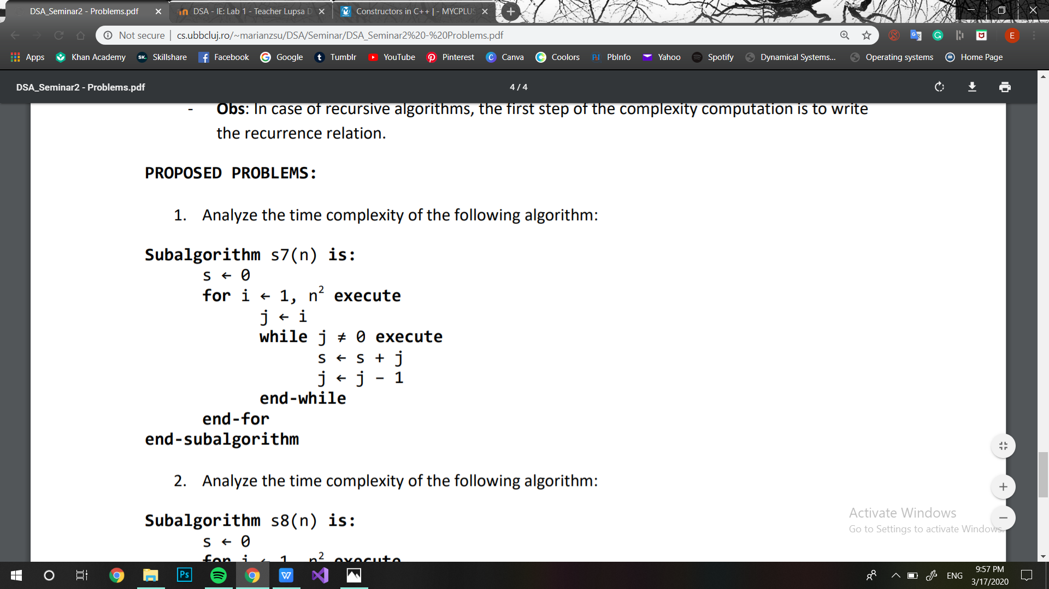

1. Here, there is no best or worst case scenario